**Wantro is an IT Company and Best Developers**

Wantro provides website development, website design, graphic design, software development, internet marketing, SEO, desktop application development, and mobile application development.

**Blog 1:**



**Business Website Importance**

A shop or a store is a face of a company, not matter how small or large a company is. It could be a warehouse or a factory outlet. However it has a face so, it could be reached by the customers, clients, partners, suppliers. But that reach is limited with respect to area, time and cost. Here are a couple of reasons to have a website



**\* Market Expansion**

A website is a face of a business for the whole world to see it. It can be approached by anyone in the world provided that a website doesn’t have any legal or political issues regarding the content it displays. Imagine an artist in Rome makes his unique prints and wants them to be famous in his own country then the whole continent and then the whole world if he decides to expand globally. A website will pace this process up.



**\* Greater Customer satisfaction**

You want to build a relationship with a customer who doesn’t know you yet alone you want them to trust you. How do you do it? Through reviews, FAQs, blogs, articles or newsletters on your own website or articles on other websites that bring you back to your own website through links. There are many bloggers, articles writers, and credible Web-Designers in Islamabad to help set up a website to promote your business and create a long-lasting relationship with your customers.



**\* A website saves you time and Money.**

A website could save you both time and money. Setting up a decent looking website does take time and money, but if you see the long-term benefits, it will save you time and money both. You can provide sufficient information on your website to your customer in so that they won’t have to search elsewhere about the products and different features and aspects of your website. A single website can be created under your budget constraint of a single newspaper ad or a billboard and the reach is many times greater with a single website. There are many Software Houses in Islamabad such as Onlineyourself.com to develop and maintain a website under a very small budget with great results for the business.



**\* Competitive Importance.**

This is a smart and savvy way to promote your business. If you are not setting up your website, then there is a good chance that your competition is. To get ahead of the competition in the local and definitely global market it is necessary to have a good website that needs to be updated time to time.

**=========================================================================**

**Blog 2:**



**State of Technology at end of 2016**

2016 is almost hitting its end so we thought it’s time to look back at the biggest trends in tech. This blogpost summarize forecasts of trends in Big Data and Data Analytics presented in Forrester and Gartner Reports. It’ll provide you a clear picture of the evolution of Big Data, predictive analytics, IoT and cloud computing market.

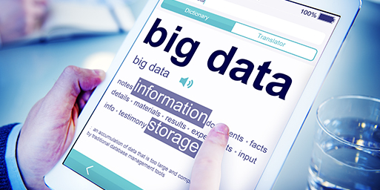

* Big Data

It has been a quiet revolution. What is trendy are the growing scale, sophistication and analytics of data. Nowadays data is not just a back-office, accounts-settling tool anymore and the Data Science is not an isolated concept. It is gaining importance in all business sectors and even within all functions. It’s increasingly used as a real-time decision making tool. Moreover, data from social networks, governments or the companies themselves are being analyzed in real time to improve efficiency. Plus thanks to Deep Learning, analytical tools will progressively become more intelligent, autonomous and intuitive in upcoming years. Their operation will gradually move closer to the way of a human thinking, so the unstructured data, such as emoticons used by online users, will be collected and analyzed more quickly and deeply.



* Self-Service Analytics

We are living in a world which is flooded with data captured from multiple sources such as corporate databases, sensors, IoT and this trend keeps increasing. In front of this rising data, organizations are innovating new tools and ecosystems to be able to translate and capture useful information from this data. One of the biggest challenge for Data Scientists is the focus on Analytics and the real-time analysis to make major decisions. To compensate the lack of qualified specialists, and in order to save time, companies will keep investing in data analysis through the Self-Service Analytics tools. With that being said, we’ll keep seeing apparition of innovative tools and other ecosystems for self-service analytics. Plus social networks will develop their own analytical tools. To remain competitive, Data Analysts will therefore have to increase their efforts and inventiveness.



* Public data sources

In the US, for instant, the aggregated health data is now open to the public through the National Center for Health Statistics of the CDC. Without any long wait, many other countries will most certainly follow the same direction. Consequently, these data can now be freely exploited by companies. Besides health, other areas should also soon open access to their data. These open data will give companies gold opportunity to adapt their products, services for niche markets.

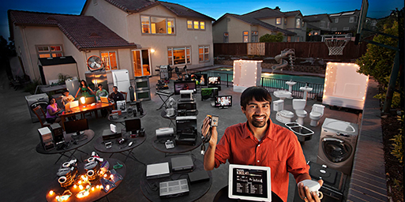

* Internet of things:

Over the past decade, the world has become increasingly hyper-connected. We live in an environment where the Internet and its associated services are accessible and immediate, where people and businesses can communicate with each other instantly, and where machines are equally interconnected with each other. IoT will continue changing everything, including ourselves in upcoming years. It’s not a bold statement, consider the impact it already has had on education, communication, business, science, government, and humanity. Clearly, the Internet is one of the most important and powerful creations in all of human history. IoT represents the next evolution of the Internet, taking a huge leap in its ability to gather, analyse, and distribute data that we have been turning into information, knowledge, and, ultimately, wisdom. The worldwide Internet of Things market spend was worth $591.7 billion in 2014 and will grow $1.3 trillion in 2019 with a compound annual growth rate of 17%.



* Cloud Computing:

Due to high costs of infrastructure and administration, data centers are often one of the first business areas that companies consider switching to a cloud service. So an organization’s decision to move their IT to the cloud is gaining importance. Most organizations are planning to shift select capabilities there, and many already have. The decision is often influenced by technology trends, except cost saving benefit, the cloud data center is much simpler to organize and operate and, because it is simple, it scales well. In other words, the larger you make it, the lower the costs per user are. My personal opinion is that organizations will soon get rid of their traditional data warehouse and invest in their next generation data warehouses which will be placed in cloud.

*For each business, the convergence of IT is an important part of their sustainable growth. All business have come to realize that an integrated IT industry will enhance the competitiveness and creativity of their economies and fuel the sustainable growth of the global economy. Businesses around the globe have been unveiling their innovative strategies for the IT industry. IT technologies have already brought a dramatic change to our lives and will continue to surprise us. We are convinced that in this new era of hyper connectivity, IT will maintain an economic growth worldwide.*

**Blog 3:**

**Security Issues reveal by Google regarding Artificial Intelligence**

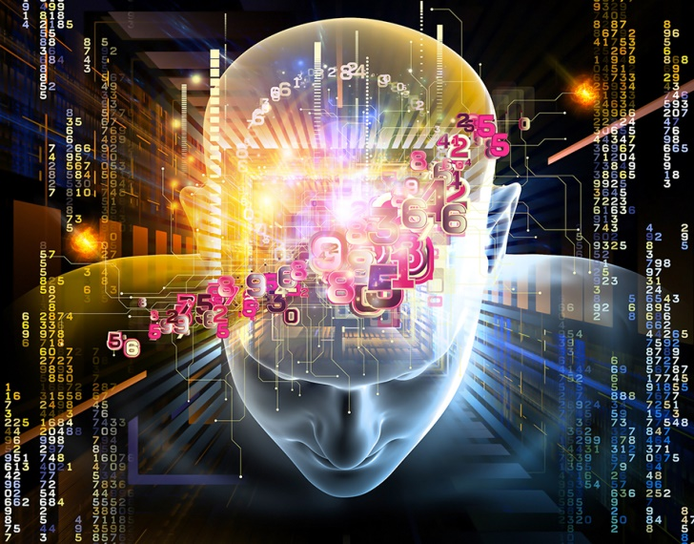

In a recent article published by Google, they’ve reveled five major security problems related to Artificial Intelligence. From now on, companies will have to fallow a guide on their future Al system in order to control robots before they can actually interact with humans.

The artificial intelligence is designed to mimic the human brain, or at least its logic when it comes to making decisions. Before worrying about whether an artificial intelligence (AI) could become so powerful that can dominate humans, it would be better to make sure that robots (also called our future colleagues and household companions) are trustworthy. That’s what Google have tried to explain us. Google’s artificial intelligence specialists have worked with researchers from the Universities of Stanford and Berkeley (California, USA) and with the Association OpenAI on **concrete** security issues that we must work to resolve.

In white paper titled “**Concrete Problems in AI Safety**” this team describes five “practical problems” of accidents in artificial intelligence based machine could cause if they aren’t designed properly. Al specialists define accidents as “unexpected and harmful behavior that may emerge from poor design of real world machine learning systems”. In short, these are not potential errors of robots we should be feared but those of their designers.

To concretely illustrate their point of view, the authors of this study voluntarily took a random example of a “cleaning robot”. However, it’s quite clear that the issues apply to all forms of AI controlling a robot.

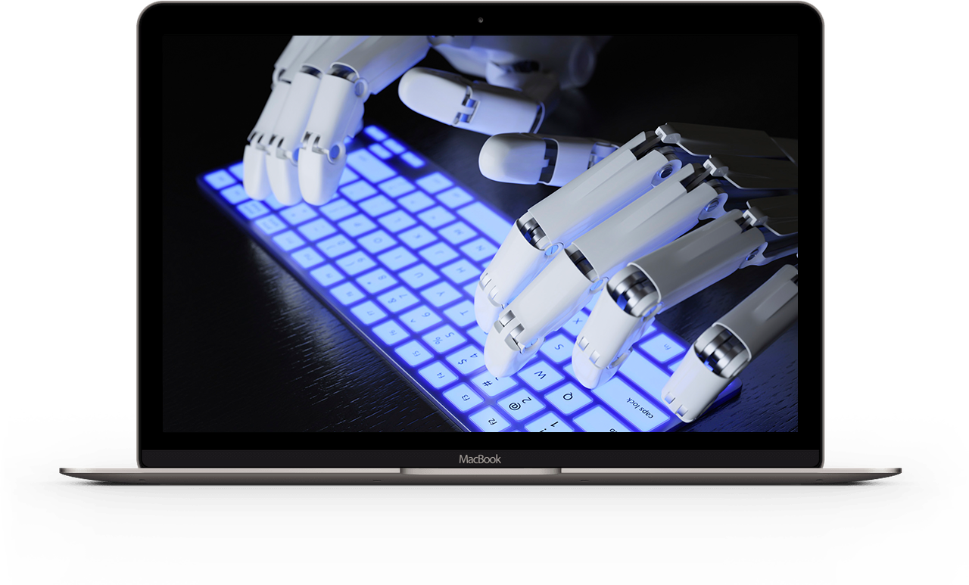

* **A robot may disrupt the environment :**

The first two risks identified by the researchers from Google and their acolytes are related to a poor coordination and allocation of the main objective. There is first what they call “Avoiding Negative Side Effects”. Specifically, how to avoid environment related problems caused by a robot while it’s accomplishing its mission. For example, the cleaner could well topple or crush what is on his way because he calculated the fastest route to complete its task. To prevent this scenario, the solution may be to create “constraints of common sense” in the form of penalties imposed on the IA when he causes a major disruption to the environment in which the robot moves.



* **The machine can cheat :**

Second risk of Al based machines is to avoiding reward hacking. For IA, the reward is the success of the goal. Avoid the quest reward from turning into a game and the machine trying to get by all means, even skip steps or cheat. In the case of cleaning robot, it would for example to hide the dirt under the rug in order to say “that’s it, I’m done.”  
A difficult problem to solve as an Al can be interpreted in many different ways a task and the environment it meets. One of the ideas in the article is to truncate the information so that the program does not have a perfect knowledge of how to get a reward and thus does not seek to go shorter or easier.

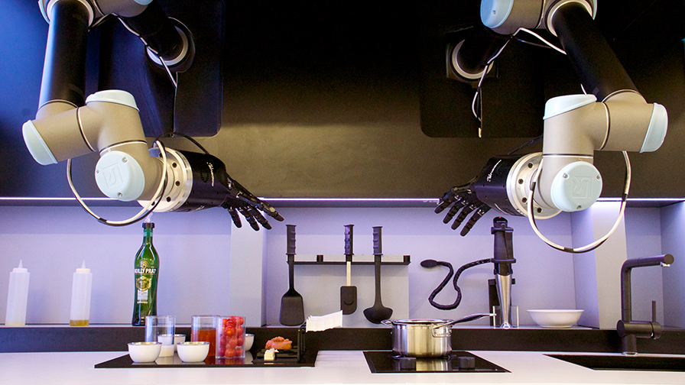

* **How to setup the robot go to the basics?**

The third risk is called scalable oversight. More the goal is complex; AI will have to validate his progress with his human referent, which would quickly become tiresome and unproductive. How to proceed so the robot can accomplish itself certain stages of its mission to be effective while knowing seek approval in situations that he will know how to interpret? Example: tidy and clean the kitchen, but ask what to do in the saucepan on the stove. It would simplify to the maximum step of the cooking task so that the robot goes to the point without coming to disturb you during your nap every time.



* **How much independence can you give to an AI?**

The next identified problem is the safe exploration of Al. How much independence can you give an AI? The whole point of artificial intelligence is that it can make progress by experimenting different approaches to evaluate the results and decide to keep the most relevant scenarios to achieve its objective. Thus, Google says, if our brave robot would be well advised to learn to perfect its handling of the sponge, we wouldn’t want it to clean an electrical outlet! The suggested solution is to train these Al with simulated environment in which their empirical experiments will not create any risk of accident.

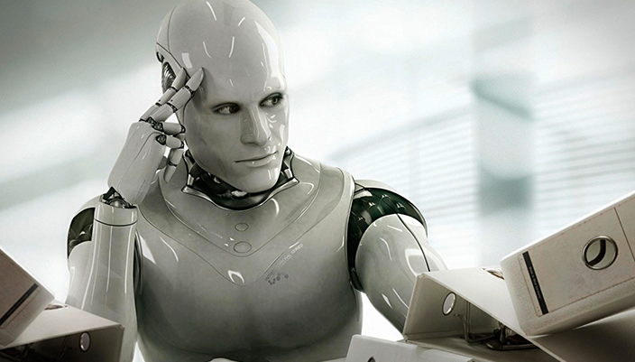

* **Does AI will adapt the change?**

Fifth and final problem: robustness to distributional shift or how to adapt to change. “How to be ensured that AI recognizes and behaves properly when it is in a very different environment from the one in which it was being driven? It is clear that we wouldn’t want the robot who was trained to wash the floor of a factory with detergent products does not apply the same technique if asked to clean home.

The article ends by saying that these problems are relatively easy to overcome with the technical means currently available but it’s better to be prudent and develop security policies that can remain effective as the autonomous systems will gain in power. Google is also working on an “emergency stop” button for all menacing AI, if eventually one or several of these risks were not fully mastered.

=================================================================

**Blog 4:**



**Business Intelligence**

Strategic information is often embedded in the volume of data information systems. In addition, these data are sometimes stored unorganized or in unstructured way. The volume of data is growing daily, it is very difficult to treat them and understand their meaning. But access to information, all information, without any delay, that’s what leaders want and that’s what BI is offering. Since past twenty years **BI** or “**Business Intelligence**” has seriously made its entry into business. But what is this software solution? Who is it for?



**Business Intelligence in Few Words:**

BI consists to transform data into information in order to predict the future development of any company. This is an IT approach that generates and processes data in order to enable leaders to have a global vision of the results of their business. Those data generated reports provide them a better analysis and understanding of the market. It is a real help in strategic decision making. Gartner findings revealed that the market for BI solutions has an annual growth of 7%.



**Business Intelligence Technology:**

Few years back, the BI was mainly used in financial sector for different departments such as accounting, management control etc. because financial institutions need to support business activities and decisions making in time. But now we all are witnessing a BI technological change and development means providing the opportunity of significant competitive advantage for all organization. Expansion of BI is having such a huge success that now it’s available to any size of organization. Not only in mode but the BI now, is a necessity of all organizations, it represents a real strength of company.

Moreover, the growing use of cloud-services clearly indicates that more and more companies choose not to waste their budget in purchase of expensive and complex software. They prefer the affordable price of services available in SaaS mode, simple and quick to implement, without cost to install or setup + access data any moment. These solutions especially have the enormous advantage of being a payback within months.



**Data Presentation Tools:**

In a company, data presentation tools offered by Business Intelligence are for everyone. Every department will find the tool that suits them best and benefit for its function.

* Management monitors business performance and effectiveness of their strategy via performance indicators presented in dashboards.
* Analysts literally navigate in information to understand and analyze the highlights of any organization.
* Finally, employees use structured reports to follow and adapt the day to day operational activities of the company.

There’s no doubt that the collaboration of these services available in SaaS mode, offers companies the opportunity to create a fluid flow of information. A well-designed BI solution provides a consolidated view of key business data which isn’t available anywhere in the organization, gives management visibility and control over measures that otherwise wouldn’t exist.